**Project Manager Assessment Documentation**

***Project Manager project has two parts,***

* Server Code which connects to the Mongo DB in the Cloud environment [have configured my mongo client]
  + Can also be modified to point to local DB in the configuration file
  + Code will generate the DB & collections based on the UI operation – no need to setup the Db up front
* Need to run the Server code in the command prompt using the node command
  + node server.js [All the code logic is in place here for the basic routes]
    - Controller folder inside the server will have each individual operation routes

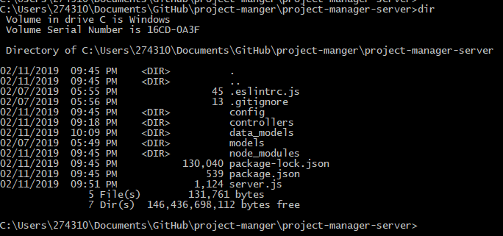

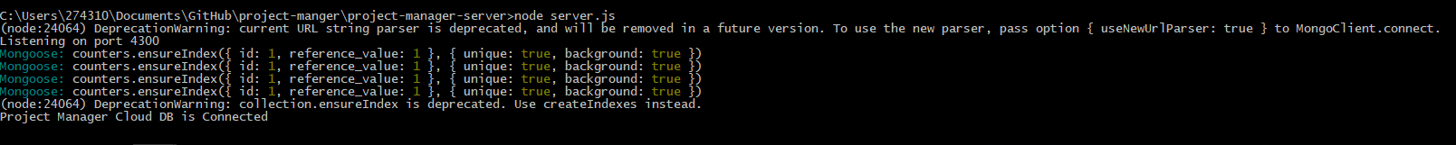

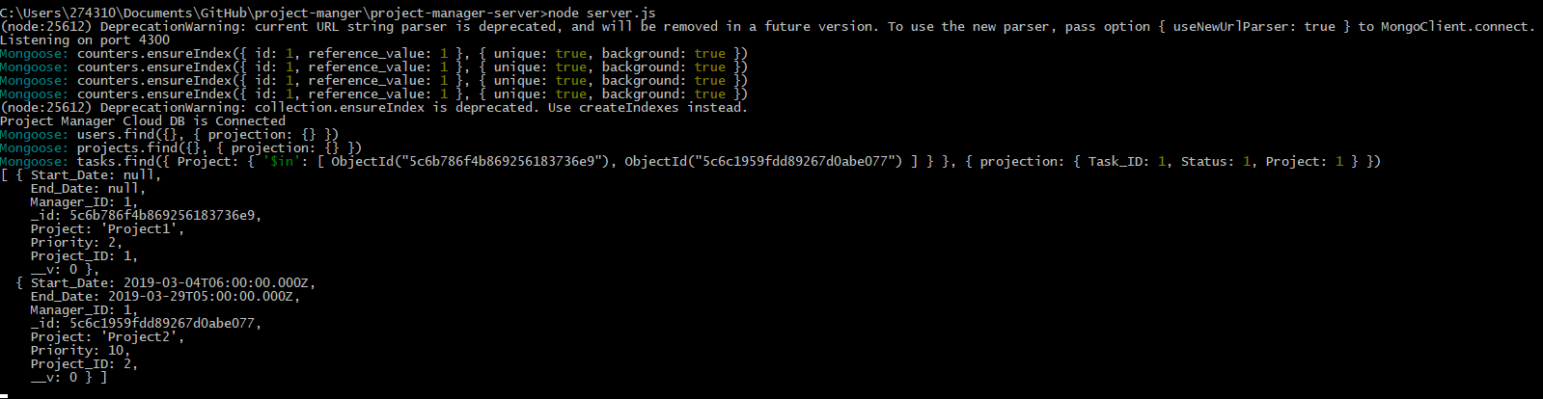

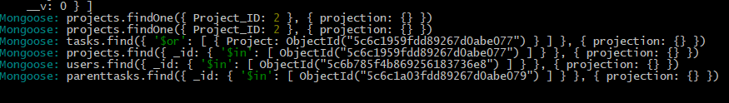

Mongo Data Routing link some samples using the Server.js program:

Localhost:4300/users

Localhost:4300/users/add

Angular UI:

* Angular Code is in the project-manager-ui folder which can be triggered or started by using the below,
  + On command line – use ng serve
    - This will start the UI in the 4200 port
    - Can be viewed by traversing to localhost:4200
  + Screen sample are as below

Below is the code repo link where both the Node Server & the Angular UI Code is present

* **Git Repo**

<https://github.com/vijayskr/project-manger>

* Code Coverage Result is in the Code GIT Repo – Coverage folder
* Test Cases are available in the specs document
* Load Test Results



**Screenshots:**

***Add/List User***

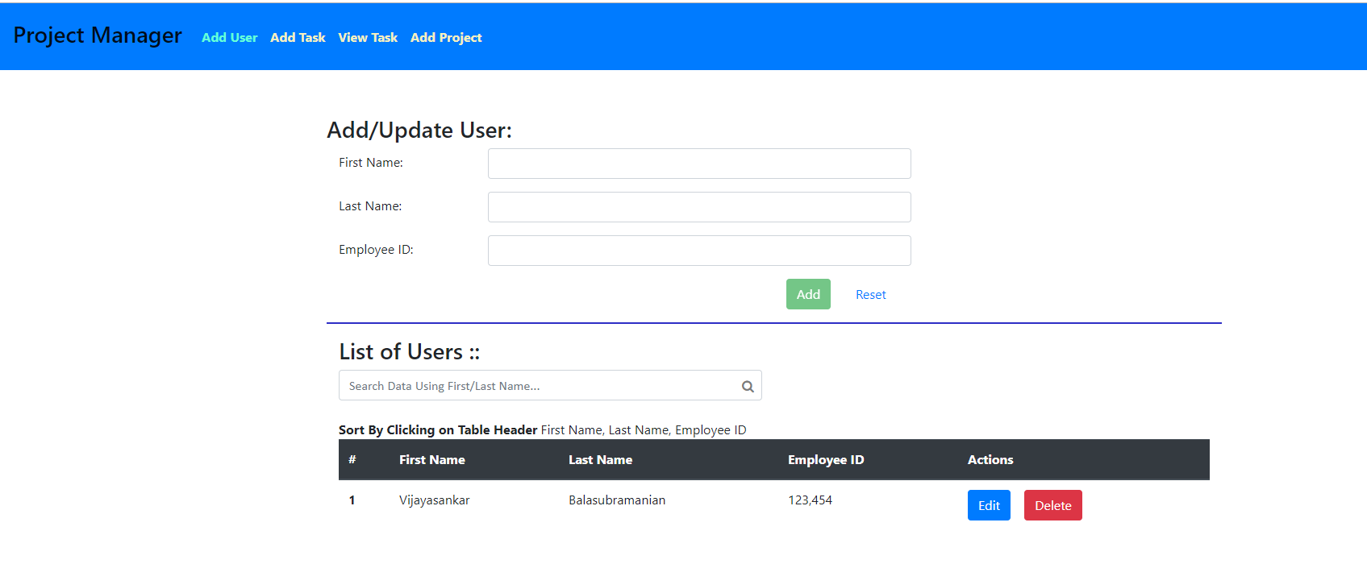

***Add Task***

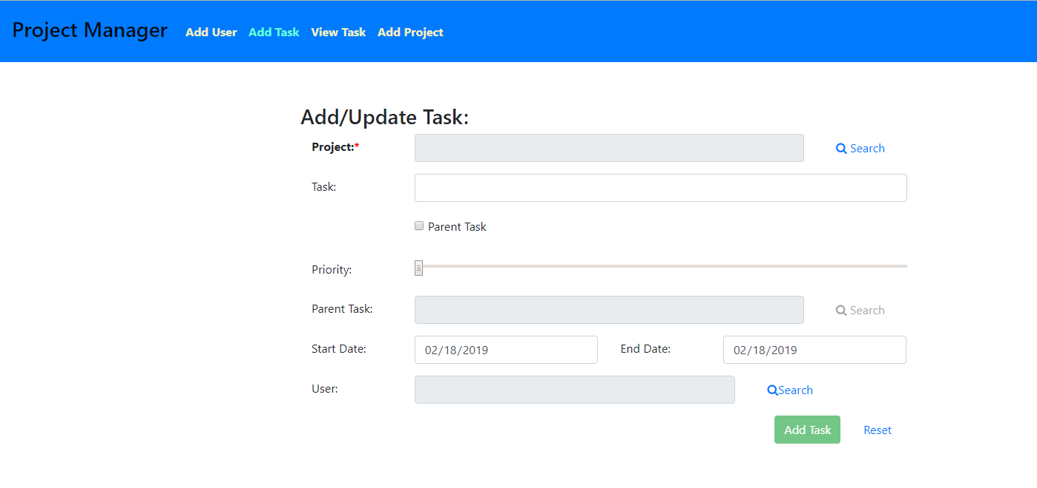

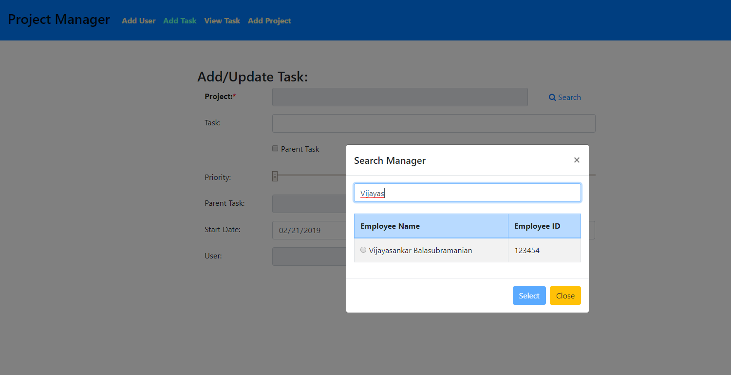

***View Task*** 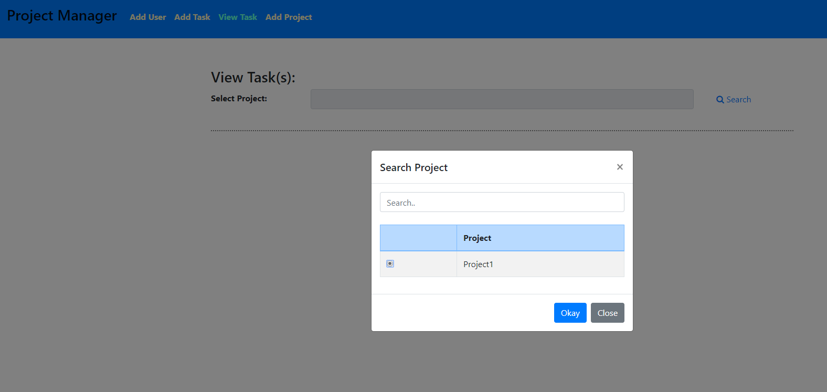

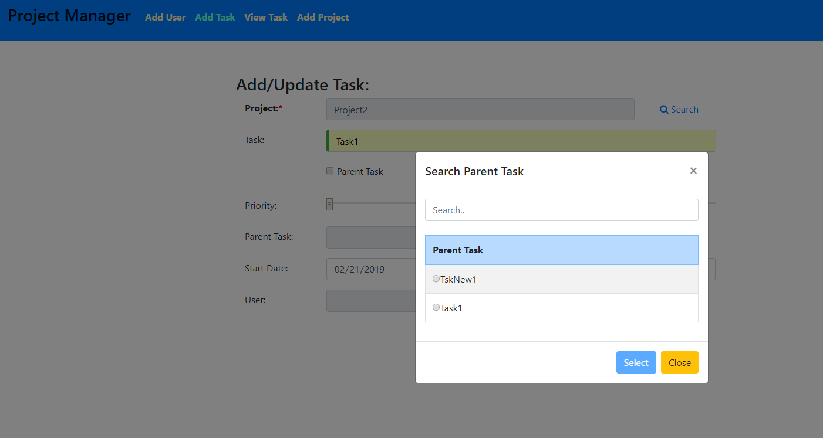

***Add/View Project***

